|  |  |
| --- | --- |
| **Name** | **Team Number** |
| **Tomoki Koike** | R06 |

AAE 251: Introduction to Aerospace Design

Assignment 4—Orbits, Aircraft Sizing, Lift and Drag

**Due Tuesday 19 February, 10:00 am on Blackboard**

**Instructions**

*This assignment has four problems—one on Hohmann transfer, one on lift and drag, and two on aircraft sizing. You can work in your teams to develop the sizing code as it will be useful to the aircraft teams in the project. As always, if you work with someone else, please indicate their name(s) on your homework. Start the HW early, or you will run out of time!*

*Carefully read the lectures notes as they will be helpful to answer the questions. If you have questions, always ask for help from the TA.*

*Write or type your answers into the appropriate boxes.* ***Make sure you submit a single PDF on Blackboard.*** *For the Matlab Code, you can either use Matlab’s publishing feature and attach that to your homework or simply copy paste the code in Word and then make a PDF.*

|  |  |  |
| --- | --- | --- |
| Problem Number | Points Possible | Points Earned |
| Problem 1 | 17 |  |
| Problem 2 | 12 |  |
| Problem 3 | 8 |  |
| Problem 4 | 20 |  |
| Total | 57 |  |

**Problem 1:**

NASA wants to move a malfunctioning spacecraft from a circular orbit at 450 km altitude to another circular orbit at 200 km altitude, so a Dragon crew can repair it. Your job as an intern at NASA is to calculate the total needed to achieve this transfer. Thankfully, you have your notes from AAE251 that illustrate how to calculate the desired velocity. However, keep in mind that in AAE251 we moved from a smaller orbit to a larger one, here NASA is doing the opposite: that is, moving from a larger orbit to a smaller one.

NASA wants you to have a labeled sketch of the transfer, the velocity required to move from larger orbit to the transfer orbit (), the velocity required to move from the transfer orbit to the smaller orbit (), and the in your report.

|  |
| --- |
| Answer 1: |

**Problem 2:**

Consider a rectangular wing with a NACA 2415 airfoil and a chord length of 4 ft. The wing is mounted with a 4 degree angle of attack in the test section of a subsonic wind tunnel, where the air is flowing at 120 mph and the pressure and density are that of the standard atmosphere at sea level. We select the wingspan such that it spans the entire width of the wind tunnel, so the flow essentially “sees” an infinite wing. The wind tunnel force balance measures a lift of lb. What is the width of the wind tunnel? Also calculate the total drag, and the moment about the quarter chord of the wing.

**Hint:** See Anderson Example 5.1 for guidance on how to solve these types of problems. Always check carefully whether the question is asking for total values, or values per unit span.

Answer 2:

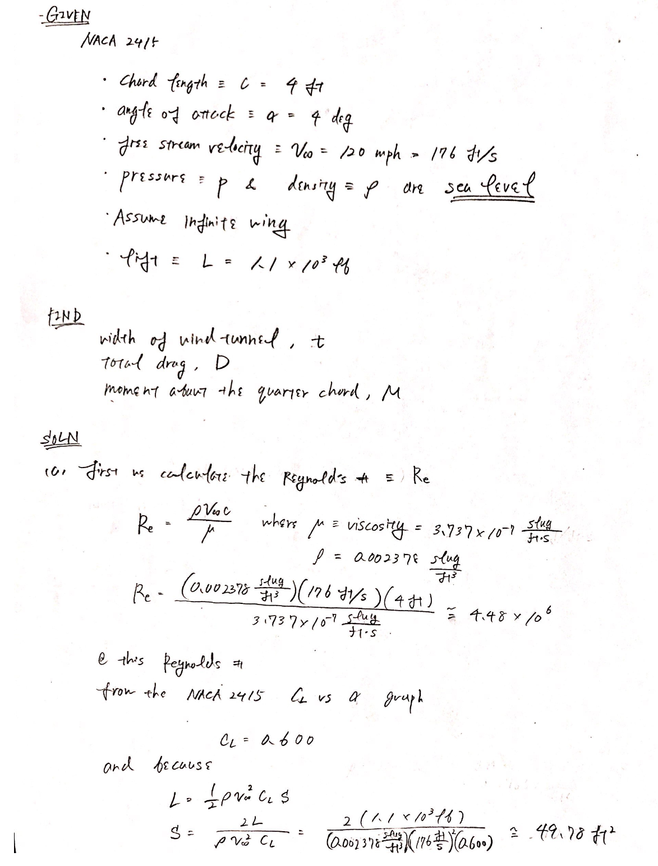

|  |
| --- |
| Answer 2: |

# Problem 3:

Aircraft design teams will be using this code in their designs. And all of you will use it again in subsequent homeworks, so make sure you code and comment well!

Chapter 3 in Raymer (download from BB) concludes with trade studies for calculating the takeoff weights of an aircraft for ranges of 1000, 1500, and 2000 nautical miles (see Boxes 1, 2, and 3, which summarize the lessons of the entire chapter).

Write a well commented Matlab algorithm that estimates the takeoff weight based on the information from the chapter. Your inputs will be range, payload weight, engine type (see Tables 3.3-4), unit type (metric, English), as well as any other inputs you deem necessary. Paste your code here: